Project
  - Deadline: Phase 1 (Mid project Progress Report) 26/07/2026 @ 23:59 Phase 2 (Final project Report) 9/8/2026 @ 23:59
[Total Mark is 20]

System Analysis and Design
IT-353

Instructions:
- You must submit two separate copies (one Word file and one PDF file) using the Assignment Template on Blackboard via the allocated folder. These files must not be in compressed format.
- It is your responsibility to check and make sure that you have uploaded both the correct files.
- Zero mark will be given if you try to bypass the SafeAssign (e.g. misspell words, remove spaces between words, hide characters, use different character sets, convert text into image or languages other than English or any kind of manipulation).
- Email submission will not be accepted.
- You are advised to make your work clear and well-presented. This includes filling your information on the cover page.
- You must use this template, failing which will result in zero mark.
- You MUST show all your work, and text must not be converted into an image, unless specified otherwise by the question.
- Late submission will result in ZERO mark.
- The work should be your own, copying from students or other resources will result in ZERO mark.
- Use Times New Roman font for all your answers.
Student Details: CRN:
Name: SHATHA KHALED  Name: MAHA Alsubaie  Name: GALA Algodah  Name: Bushra Alshayeb  Name: Hesa Abdullah |  | ID: S240067735  ID:s240025765  ID:s240031741  ID:s240057076  ID: s240041770

Project submission guidelines and instructions
- Mid project Progress Report:
Students are required to submit a short mid progress report, which must include:
  - Work completed this period
  - One key decision has been made during this period
  - One problem encountered
  - Plan to do next.
  - Each group member input/participation.
  - A link to each group member GitHub repository
- Version History / Commit Log Requirements:
Each group member must complete and submit project history/timestamp using a live, editable GitHub link. The repository must show commit history reflecting incremental progress. commit regularly (at minimum once per week), with clear, descriptive commit messages.
A separate section in the report must be added and named “Project Artifacts" to include each student’s name and a link to his/her GitHub repository (with commit history).
What NOT to do: Students must not write their report elsewhere and paste the final version in at the last minute. They also should not make a single commit containing your entire files. Both are treated as red flags regardless of the quality of the final work.
- Written Reflection (End of Project Report):
The project report should include a Reflection section (300–500 words) as the last section (one section for each student). This section must be written in students’ own words and should address some of the following:
  - Describe one specific challenge or obstacle you encountered during this project and explain in detail how you identified and resolved it.
  - Explain why you chose your specific approach/method/model over at least one alternative you considered, and what tradeoffs informed that decision.
  - If you used any AI tools during this project (e.g., ChatGPT, Claude, Copilot), disclose which tool(s), for what specific purpose (e.g., debugging, grammar checking, brainstorming), and how you verified or modified the output.
  - What would you do differently if you were to redo this project with more time or resources?

Important Notes
- AI use: Students may use AI tools (ChatGPT, Claude, Copilot, Gemini, etc.) only for brainstorming approaches, debugging small errors, or proofreading text. AI must not be used to generate analysis, write code logic, or produce substantial portions of report or codebase. Any permitted AI use must be disclosed in Reflection section. Undisclosed AI use, or AI use beyond this scope (disclosed or not), will result in a zero grade for the entire project.
- Any submission lacking a valid, inspectable version/commit history, or showing evidence of AI generation or plagiarism, will receive a zero grade for the entire project.
- Failure to submit mid progress reports as required, or submission of reports found to be fabricated, copied, or AI-generated, will result in a zero grade for the entire project.

Project Rubric

Component | Weight | Note
Final report/deliverable | 85% | Core assessment of the work itself.
Mid Progress report | 10% | Incentivizes engagement across the timeline, not just at the end. Absence blocks credit for the whole project.
Version/commit history | Pass/fail | Not a grade component. Absence blocks credit for the whole project.
Reflection section | 5% | Rewards demonstrated understanding and honest disclosure.

Scenario

The Saudi Electronic University (SEU) currently organizes a wide variety of extracurricular activities, including workshops, seminars, competitions, volunteering opportunities, social events, career development sessions, and sports activities. However, information about these activities is scattered across emails, social media platforms, and announcements, making it difficult for students to discover upcoming events and register for them. Activity organizers also face challenges in managing registrations, tracking attendance, monitoring participation limits, and preparing reports.
Learning Outcome(s):
Illustrate most common analysis and design techniques in the form of a group project.

To address these issues, SEU plans to develop a Student Activities Management System (SAMS) that will provide a centralized platform for managing all student activities. The proposed system should allow students to browse available activities by category, campus, or date, view detailed information about each activity, reserve a seat, cancel a reservation before the registration deadline, receive notifications and reminders, and record their attendance by scanning a QR code or using another electronic attendance method at the event. Students should also be able to view their personal activity history throughout their studies, including the number of activities attended, participation hours, certificates earned, and achievements. Upon graduation, the system should automatically generate a comprehensive Student Activity Report (Activity Transcript) summarizing all extracurricular activities completed during the student's academic journey.
Activity organizers should be able to create, edit, publish, and cancel activities, define participant limits, registration periods, locations (physical or virtual), attendance methods, and eligibility requirements. Organizers should also manage participant lists, approve registrations when required, record attendance, issue participation certificates, and generate reports on attendance rates and student engagement.
The Student Affairs Department should oversee the entire system by managing activity categories, approving activities submitted by organizers, monitoring participation statistics across all university branches, generating institutional reports, and ensuring that each student's activity transcript is accurate and complete before graduation.
The system should also support notifications for registration confirmations, activity reminders, cancellations, and waitlist updates. If an activity reaches its maximum capacity, additional students should automatically be placed on a waiting list and promoted when vacancies become available.
The university expects the new system to improve student engagement, simplify activity management, eliminate manual attendance tracking, and provide accurate records of students' extracurricular involvement throughout their university studies.
Based on the above scenario, complete the following tasks.

Task 1
Develop a Gantt Chart for the project, including major development activities, durations, and dependencies. [1.5 marks]
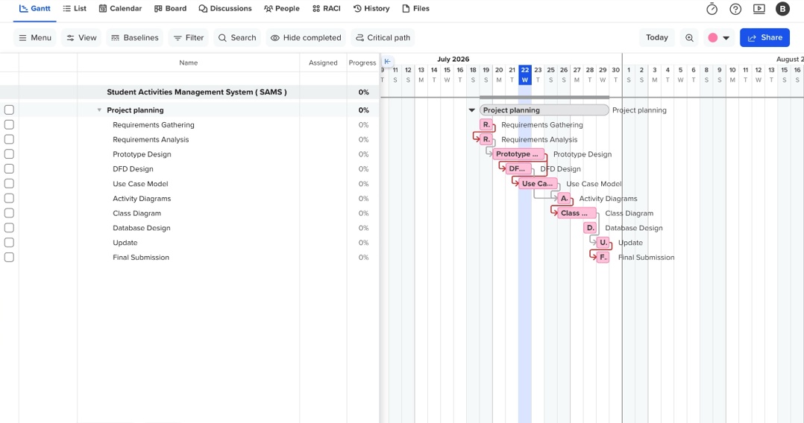
Major development actives:
- Requirements Gathering
- Requirements Analysis
- Prototype Design
- DFD Design
- Use Case Model
- Activity Diagrams
- Class Diagram
- Database Design
- Update
- Final Submission

Activity | Duration | Dependency
Task 1 : Develop Gant chart | 1day | -
Task 2: Develop Low-Fidelity Prototypes | 3 days | After Task 1
Task 3: Develop Data Flow Diagrams (DADs) | 4 days | After Task 2
Task 4: Develop Use Case Model | 4 days | After Task 3

Start

Task 1: Gantt Chart (1 day)
Task 2: Low-Fidelity Prototype (3 days)
Task 3: Data Flow Diagrams (4 days)
Task 4: Use Case Model (4 days)
End
The whole team worked on the first four tasks (Gantt Chart, Low-Fidelity Prototype, DFDs and Use Case Model) with each member working on separate parts of the project and with different experiences:
Shatha:
Shatha was tasked with designing the project timeline, which included creating Gantt Chart as well as sequencing and dependency Ing tasks. She also assisted in nailing down system requirements, which allowed the team to keep a demonstrable timeline and workflow for the project.
Bushra:
Bushra wrote the Data Flow Diagrams (Context Diagram, Level-0 DFD and Level-1 DFDs). She has made sure that only the right number of processes and data movement have been represented and consistently throughout the analysis.
Gala:
Gala used Figma to create the low-fi prototypes, It was one of her first interface design experiences and through multiple iterations she refined the screen layouts, with simplicity and easy-to-use design as priorities.
Maha:
Maha followed through and worked in creating the Use Case Model identifying system actors, creating the Use Case Diagram and documenting detailed use cases. This also allowed her to understand the use of UML in describing user interaction with the system along with converting system requirements into functional models.
Hessa:
Hessa went through the analysis models and made sure that there was consistency between the prototypes, DFDs, and Use Cases. During team discussions, she would also volunteer some thoughts and assist in terms of diagrams & documentation refining to achieve more quality product

Task 2
- Select ONE prototyping approach
- (Evolutionary Prototyping or Throwaway Prototyping).
- Develop low-fidelity prototypes for 3 main screens
of the system and justify why your chosen approach is more appropriate for this project. [2 marks]
Selected Prototyping Approach
- Evolutionary Prototyping

Justification

Evolutionary Prototyping was opted for as this allows step by step system improvement based on user feedback. A student in a more robust duration approach is suitable since features getting implemented in the Student Activities Management System are browsing activities, registration, notifications, attendance tracking and activity management and it cannot be obtained by an individual easily. It allows the team to better understand user needs, improve during development, and decrease the likelihood of developing a system that fails to be what users need.

Low-Fidelity Prototype Screens

Screen 1: Home
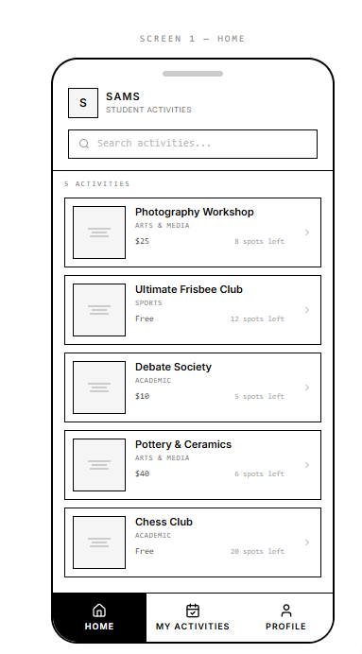
Screen 2: My Activities
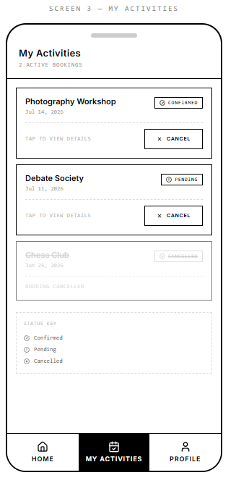

Screen three: Activity details & registration
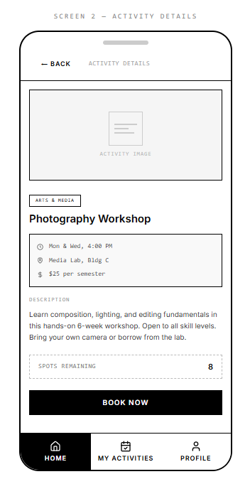
In task 2,since the team designed the low fidelity prototype independently as a team and each member have different challenges:

Gala: The first experience of working with Figma, and at first she struggle to organize the screens in an easy and useful way but by making a couple of revisions, we found that you must think about simplicity.

Maha: finally was able to use Figma (after a while she never had any editing feature experience) as her project meant so much at this stage, she found prototyping essential before even thinking about developing a system.

Hessa: It was particularly difficult for to lay out the content on each screen so that it did not come off as overcrowded, and after rereading this project a few times I emphasize how important simplicity and consistency are in the interface. It was between doing these that

Shatha: and Asiri found it difficult to move the whole system requirements into screen layouts or wireframes that can be useful for the implementation, this also helped her to learn what is user interface design better by just preparation

Bushra: made sure that all the screens in the prototype were semantically linked together with a seamless user flow. Going through the design process with the team, she learned to improve, collaboration. This includes constant feedback, nit-picking to create a prototype that works

Task 3
Develop the Data Flow Diagrams (DFDs):
- Context Diagram
- Level-0 DFD
- Three Level-1 DFD for 3 major processes [2.5 marks]

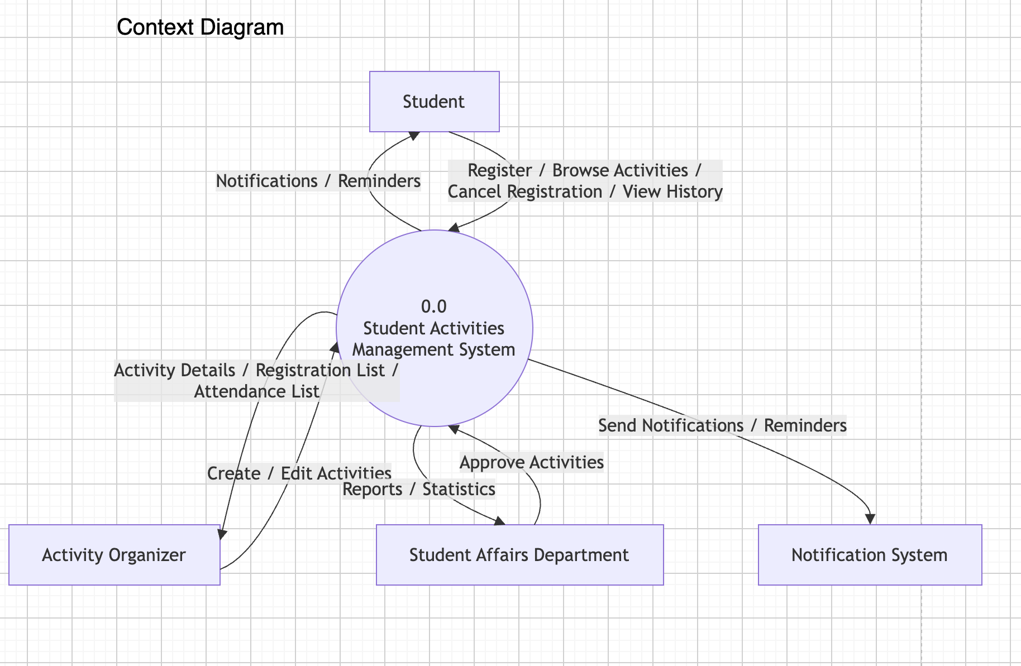

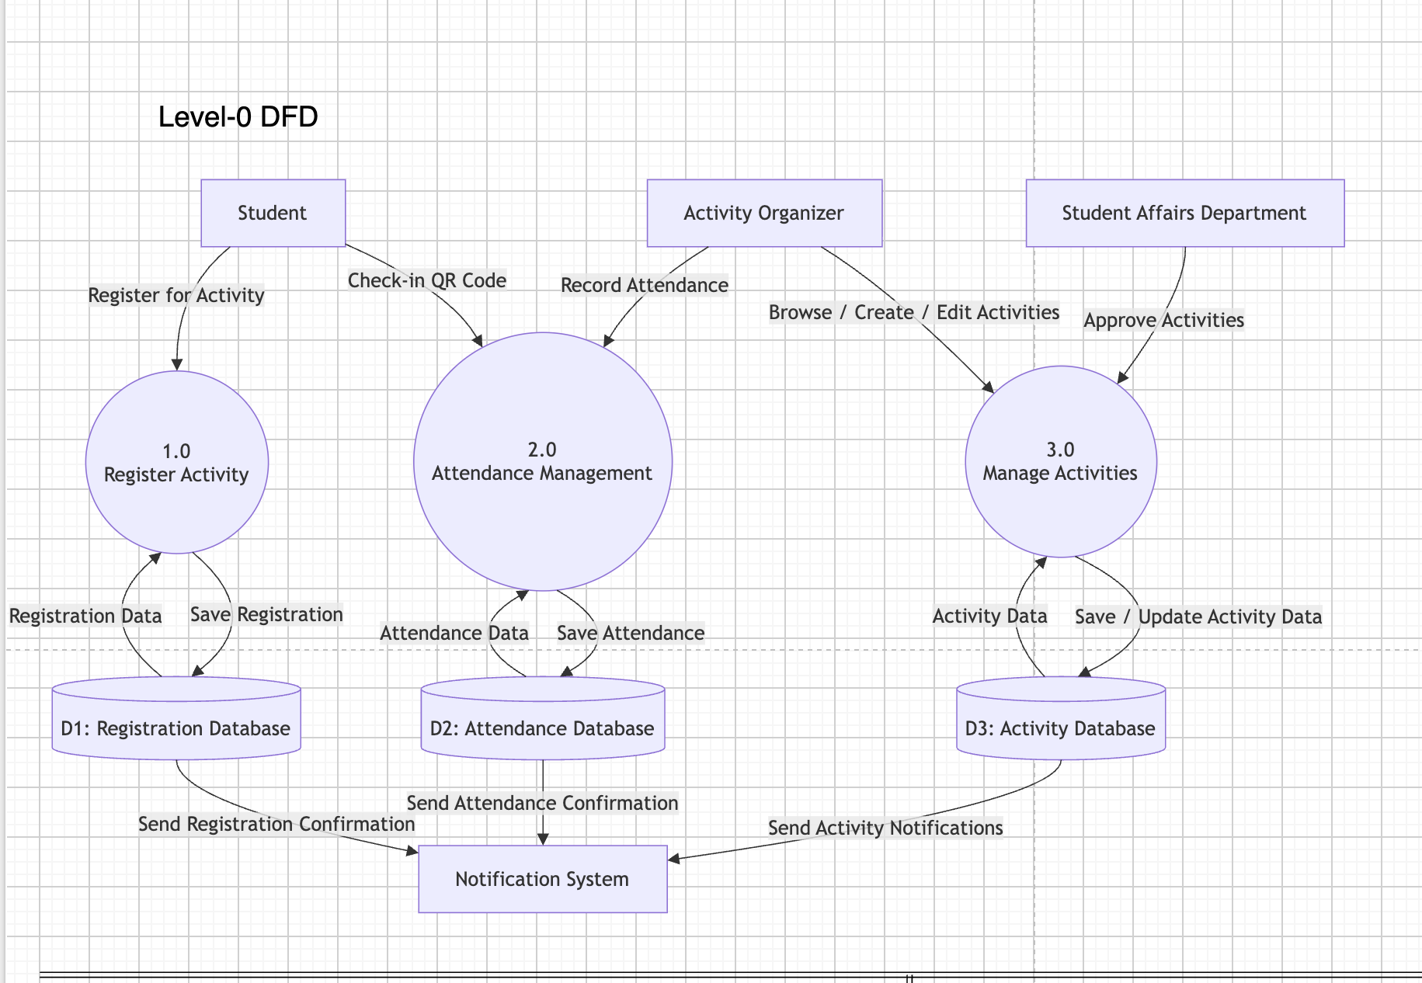

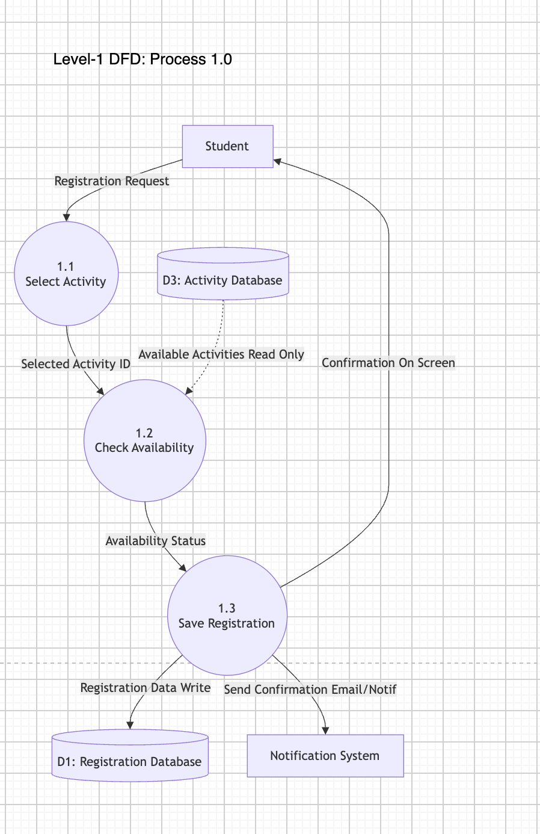

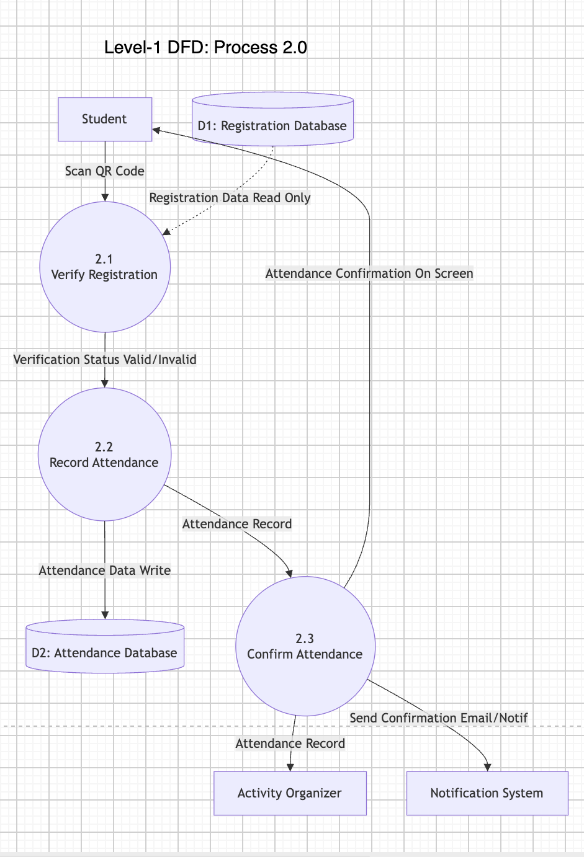

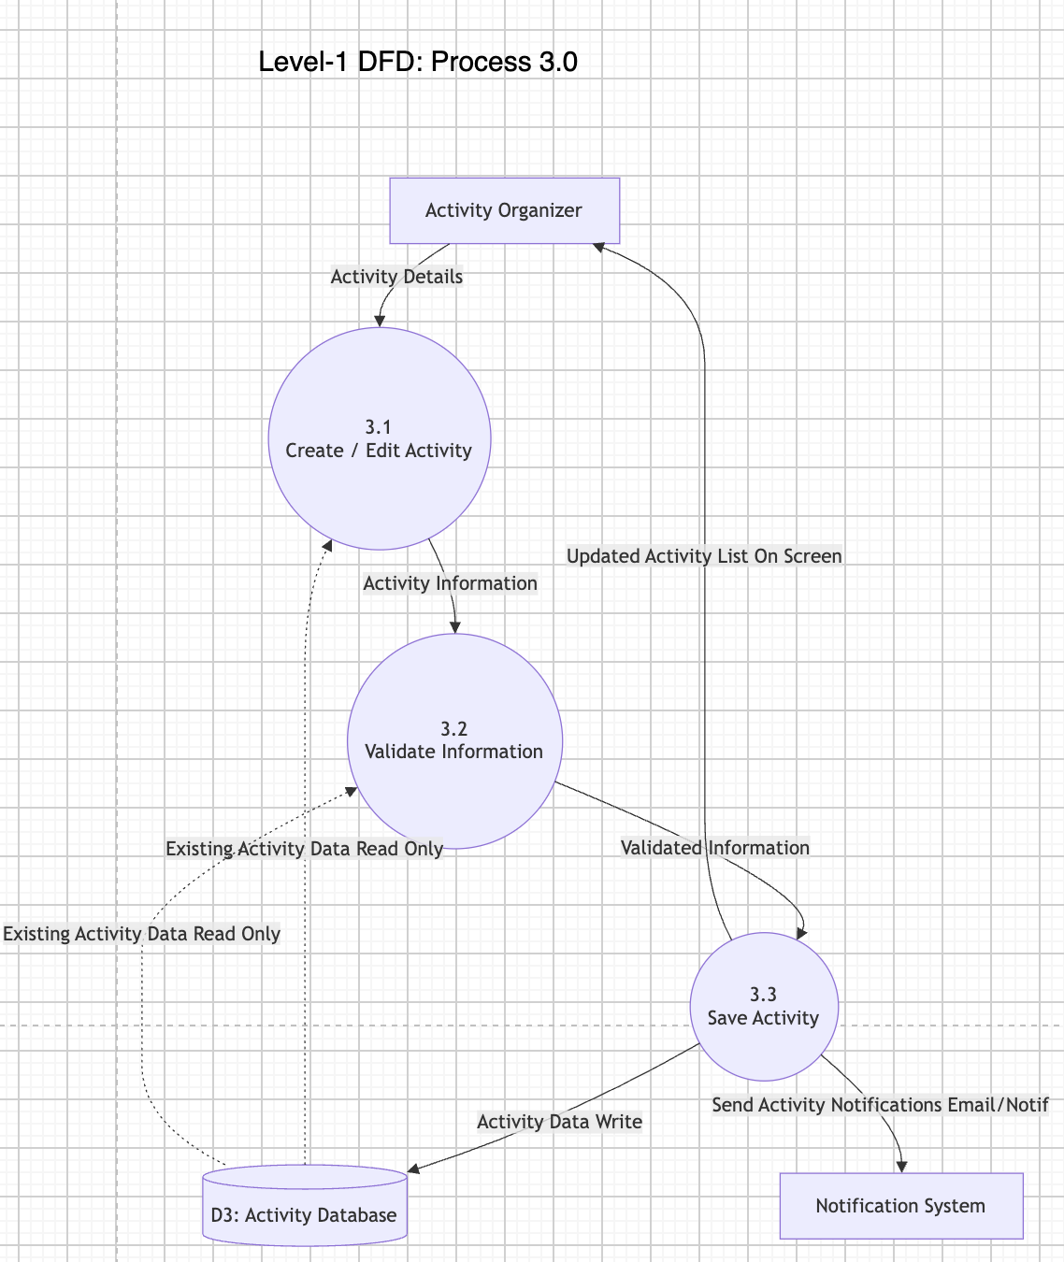

Shatha's task is to create the Context Diagram. She modelled the whole system as one process and demonstrated its interaction with the outside world in terms of data flows.
Challenges Faced
Identifying the correct external entities.
Data flow: It defines the data flow between system and external entities.

Ghala’s task was to create the Level-0 DFD by breaking the system into its processes. She demonstrated how data moves between the entities, the processes, and the data stores.

Challenges Faced

Figuring out the processes.
Linking the data flows.
Making sure the diagram stayed the same as the Context Diagram.

Maha’s task was to create the Level-1 DFD for Process 1. She had to break Process 1 into parts and show how the data moves around in detail.

Challenges Faced

* Breaking Process 1 into subprocesses that make sense.
* Figuring out the way that the data flows.
* Making sure the Level-1 DFD for Process 1 matches the Level-0 DFD, for Process

My task was to create the Level-1 DFD for Process 2 for the Payment process. She divided it into four subprocesses: Enter Payment, Verify Payment, Save Payment, and Send Receipt, showing the flow of payment data.

Challenges Faced

Breaking the payment process into subprocesses.
Identifying the data flow.
Keeping the Level-1 DFD with the Level-0 DFD

Bushra had to make the Level-1 DFD Process 3 for the User Management process. This was her task. She broke it down into four parts: Register, Login, Update Profile, and Logout. The User Management process was divided into these subprocesses. This showed how the User Management process works and how user information moves through the system. The User Management process was the focus.

Challenges Faced

Bushra faced challenges. One challenge was breaking the User Management process into subprocesses. Another challenge was finding the data flow for the User Management process. She also had to keep the Level-1 DFD consistent with the Level-0 DFD for the User Management process. This was important for the User Management process.

Task 4
Develop the Use Case Model:
- Identify all system actors.
- Create one complete Use Case Diagram.
- Fully document three use cases using the use case template. [3 marks]
System Actors:
Based on the Student Activities Management System ( SAMS ) scenario , the actors interact with system :

Student​:
browse, book an activity, cancel bookings, register attendance electronically, see personal activity history and transcript.

Activity Organizer:
Create, edit and publish activities, venue and participant limitations update. Register participants for an activity, manage the list of participants in different sessions of each event (dates or locations), record attendance on all days Participants can be issued with a certificate and generate attendance reports.

Student Affairs Department: Responsible for system level oversight and controls, manages categories of activities, approves/rejects submitted activities and monitors institutional reporting statistics as well as student transcripts.
Student Affairs Department: Responsible for system level oversight and controls, manages categories of activities, approves/rejects submitted activities and monitors institutional reporting statistics as well as student transcripts.

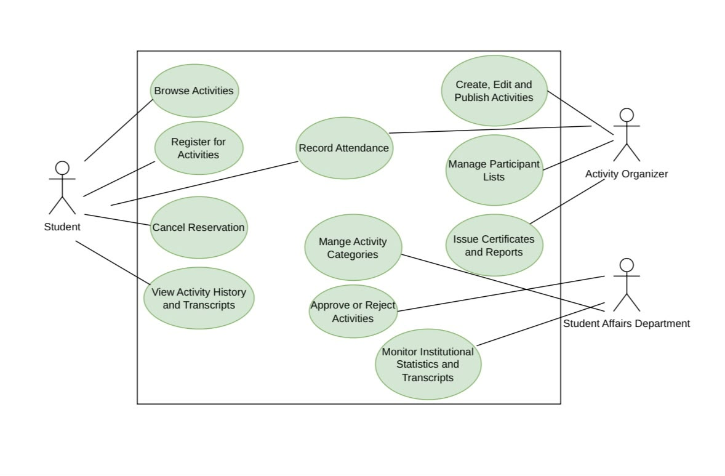

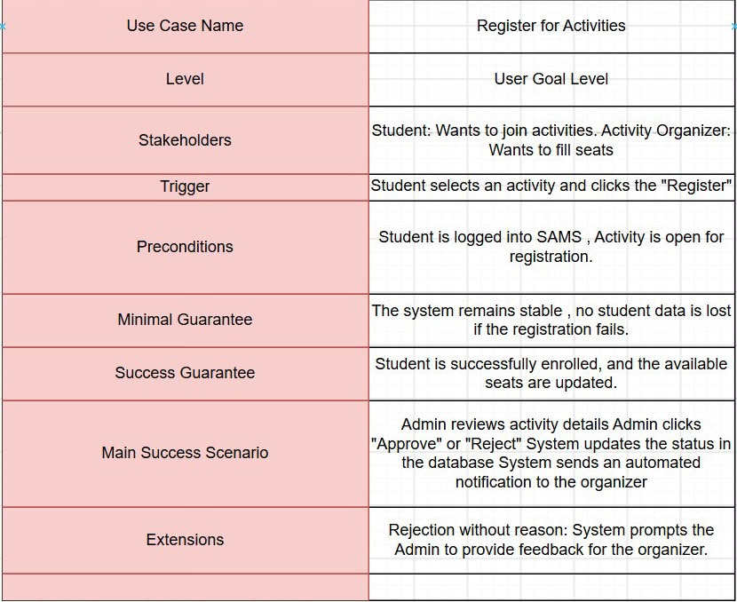

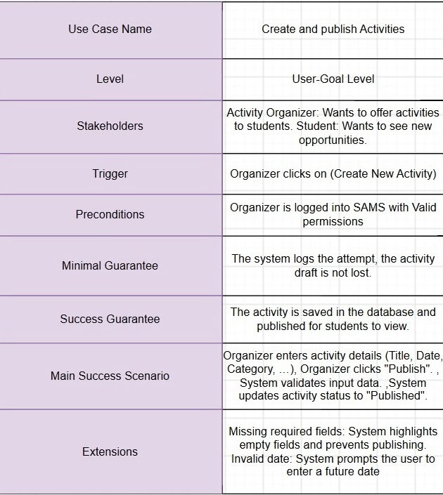

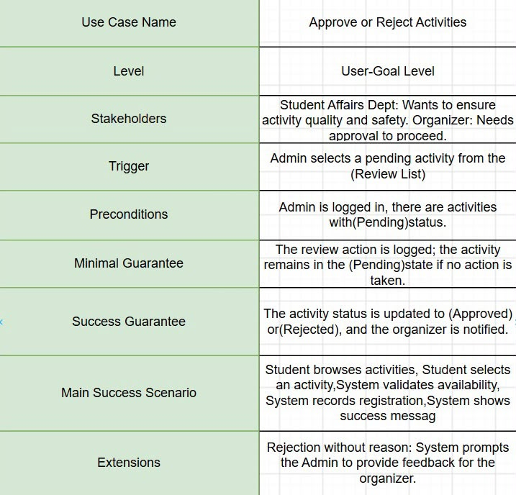

Shatha:
Identified the system actors (Student, Activity Organizer, Student Affairs Department).
Helped define the responsibilities of each actor in the system.
Reviewed the consistency between actors and use cases.
Bushra:
Designed the Use Case Diagram
Connected all actors with their corresponding use cases.
Verified that the diagram matched the project requirements.
Ghala:
Documented the Register for Activities use case.
Completed the use case template including stakeholders, trigger, preconditions, success guarantee, main success scenario, and extensions.
Maha:
Documented the Create and Publish Activities use case.
Defined the workflow and alternative scenarios.
Reviewed the completeness of the documentation.
Hessa:
Documented the Approve or Reject Activities use case.
Reviewed the entire Task 4 document for formatting and consistency.
Finalized the report before submission.

Reflection:
‏Working on the Student Activities Management System project was a great experience for our team. We got to use the things we learned in the System Analysis and Design course in a situation At first we thought it would be about making diagrams but it turned out that every task was connected to the others. We had to make sure the prototype, Data Flow Diagrams and Use Case Model all showed the system, which took a lot of planning talking and working together.
‏One of the parts was making the Use Case Model. Finding the system actors was not too bad. Writing down the use cases in enough detail and making sure they fit the project requirements was tougher than we thought. We had to include the preconditions, main success scenario, alternative flows and postconditions for each use case To get past this we looked at the project scenario times compared the use cases with the prototype and Data Flow Diagrams and talked about any confusing points until we agreed on a solution.
‏We chose the Evolutionary Prototyping approach because it seemed better for this project than Throwaway Prototyping. The Student Activities Management System has a lot of features like looking at activities signing up tracking attendance sending notifications and managing activities. We thought our understanding of what was needed would get better as we worked on the project. This approach let us improve the prototype bit by bit and make changes as needed of making one that would be thrown away.

‏We used ChatGPT as a tool to help us. We used it to organize our ideas make our writing better and clarify things. We also used it to brainstorm when we were stuck, on how to explain something.. We always checked what it said made sure it fit the project requirements and wrote it in our own words so it was accurate and followed the project rules.

‏If we could do the project again we would take time to review each task before moving on to the next one. We would also have meetings to find inconsistencies early and work better together. Overall this project helped us think critically work together communicate and understand how different system analysis models work together to design a complete information system, which is the Student Activities Management System

Github Link:
https://github.com/GalaAlgodah/IT353-SAMS-Project

Task 5
Develop two UML Activity Diagrams for two major business processes. [2 marks]

Task 6
Develop a UML Class Diagram including classes, attributes, methods, associations, multiplicities, and inheritance where appropriate. [3 marks]

Task 7
Design the relational database, including tables, primary keys, foreign keys, appropriate data types, and normalization (up to at least Third Normal Form). [3 marks]

